**PAPER’S TITLE**

I.I. Ivanov1, P.P. Petrov2, S.S. Sidorov3

*1Tomsk Polytechnic University, Tomsk, Russia,* [*ivanov@gmail.com*](mailto:ivanov@gmail.com)

*2Tomsk State University, Tomsk, Russia,* [*petrov@mail.ru*](mailto:petrov@mail.ru)

*3V.S. Sobolev Institute of Geology and Mineralogy SB RAS, Novosibirsk, Russia,* [*sidorov@yandex.ru*](mailto:sidorov@yandex.ru)

**Abstract:** The text of the abstract is given in English and is typed in the same way as the main text of the abstracts. The volume of the abstract is up to 100 words.

**Introduction**

Text

**Materials and methods**

Text

**Results and discussion**

Text

***Table 1.*** *The heading of the table*

|  |  |  |  |  |
| --- | --- | --- | --- | --- |
| **Headline** | **Headline** | **Headline** | **Headline** | **Headline** |
|  |  |  |  |  |
|  |  |  |  |  |
|  |  |  |  |  |
|  |  |  |  |  |
|  |  |  |  |  |
|  |  |  |  |  |
|  |  |  |  |  |
|  |  |  |  |  |
|  |  |  |  |  |

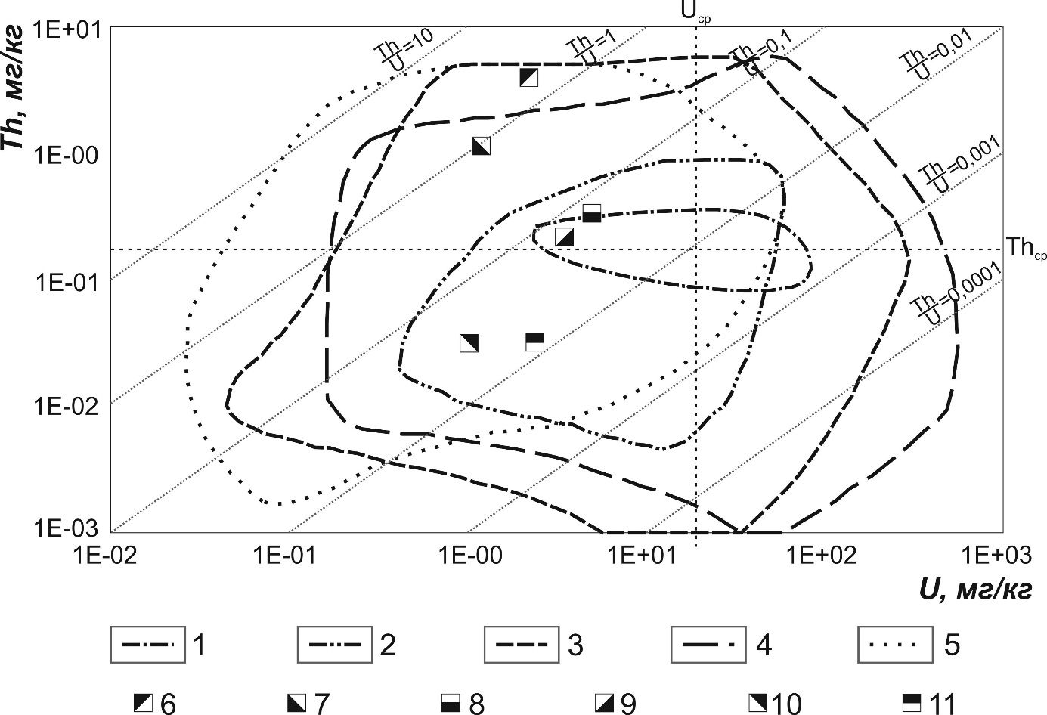

***Fig. 1.*** *The heading of the figure*

**Conclusion**

Text

*Acknowledgements (if necessary)*

**References**