Study on the Mechanism of Ionic Liquids-Modified TiO₂ Nanotubes Enhancing Photoreduction of CO₂ to Acetic Acid
Irina V. SOKOLOVA^{1,*} [0000-1111-2222-3333], Kai LIU² and Hui HU¹
¹ Vernadsky Institute of Geochemistry and Analytical Chemistry, Russian Academy of Sciences, 19, Kosygin St., 119991, Moscow, Russia
² State Key Laboratory of Intelligent Manufacturing Equipment and Technology, Huazhong University of Science and Technology, Wuhan, China
E-mail of the corresponding author: sokolova@geokhi.ru
Abstract. Photocatalytic reduction of CO₂ to produce chemical fuels is considered a green approach, as it can address the environmental and social issues caused by rising CO₂ concentrations while also mitigating the energy crisis. Ionic liquids (ILs) have been widely used in CO₂ capture. Surface modification of TiO₂ nanotubes (TNTs) with ILs promises simultaneous CO₂ capture and reduction to chemicals. This study first optimized the anodization process of TNTs by adjusting the water content, achieving a tubular array microstructure with optimal photocatalytic performance. Subsequently, the ILs with the best CO₂ enrichment performance were selected to modify the surface of the TNTs. The resulting nanocomposite achieved a photocatalytic reduction of CO₂ to acetic acid under simulated sunlight, with an acetic acid yield of 17.4 μmol gcat⁻¹ h⁻¹. After five cycles, there was no significant decline in acetic acid production. The surface modification of the ILs facilitated the enrichment and activation of CO₂ from the water solution onto the catalyst surface. The presence of a large amount of activated CO₂ and single-C intermediates on the catalyst surface increased the probability of C-C coupling, thereby promoting the formation of the two-carbon product, acetic acid.

Keywords: Photocatalytic CO₂RR, Acetic acid, Ionic liquids
- Introduction
The rising concentration of CO₂ leads to climate change, which triggers a series of environmental and social issues [1]. Consequently, the development of carbon capture and storage technology has garnered increasing attention and effort from researchers [2]. Among these technologies, photocatalytic CO₂ reduction to produce chemicals is analogous to natural photosynthesis, hence it is also referred to as artificial photosynthesis [3]. It involves the absorption of sunlight by photocatalysts, resulting in electron transitions to form photogenerated electron-hole pairs. The photogenerated electrons combine with CO₂ and reduce it to chemicals, while the photogenerated holes combine with H₂O and oxidize it to oxygen and provide protons [4]. However, current photocatalysts are limited by their band gaps and can only utilize a small fraction of ultraviolet light in sunlight. Therefore, modifying the band structure of catalysts through band engineering to enhance their solar absorption can effectively boost the activity of photocatalytic reactions. In this study, TiO₂ nanotubes (TNTs) were first synthesized. Their unique nanotube structure enables the utilization of sunlight from the traditional ultraviolet region to the visible and infrared regions. The water content in the electrolyte during the anodization process was optimized to produce TNTs with various morphologies, and TNTs with the best photocatalytic performance were selected as the substrate for the nanocomposite.
Ionic liquids (ILs), known for their stable chemical properties and tunable cations and anions [5], have been widely used in CO₂ capture [6]. Studies have shown that surface modification of ionic liquids can promote the activation of CO₂ molecules on the catalyst surface, facilitating the subsequent reduction reactions [7]. Ionic liquids have also been extensively applied in photocatalysis [8]. Research indicates that surface loading of ionic liquids can effectively enhance the separation of photogenerated electron-hole pairs, reducing their recombination and thereby improving photocatalytic activity [9]. It has been found that the type of anion in ionic liquids significantly influences their CO₂ solubility. Therefore, this study selected imidazolium-based ionic liquids with the same cation but different anions to identify the one with the highest CO₂ solubility. This target ionic liquid was then used to modify the surface of TNTs to create a nanocomposite photocatalyst. The resulting photocatalyst can enrich CO₂ from aqueous solutions and reduce it in situ to produce the two-carbon product acetic acid.
- Materials and methods
  - Materials
TNTs were prepared using an anodization method. The process involves initially cleaning the Ti plate with acetone, anhydrous ethanol, and deionized water to obtain a clean surface. The Ti plate is then etched for 2 min in a solution with a volume ratio of HF: HNO₃: H₂O at 1:3:6, resulting in a polished surface. The treated Ti plate serves as the anode, and Pt is used as the cathode, with the electrolyte being an ethylene glycol solution containing 0.25 wt% NH₄F. Anodization is performed at 60 V DC for 8 h to form the precursor, which is then rinsed with deionized water, dried, and calcined at 450°C for 2 hours. To explore the effect of water content in the electrolyte on the morphology of the TNTs, different water content gradients (14, 10, and 5 vol%) were set, resulting in samples denoted as TNTs-1, TNTs-2, and TNTs-3, respectively.
The ILs surface modification was achieved through a solvent evaporation method. An appropriate amount of ILs was ultrasonically dispersed in acetone, and the prepared TNTs were placed in the dispersed solution and stirred thoroughly for 30 minutes. The mixed solution and samples were then placed in a vacuum-drying oven and dried overnight at 60°C. The samples were washed with deionized water and dried with N₂ to obtain the ionic liquid surface-modified TNTs, denoted as ILs-TNTs.
  - Characterization
The microstructure of the TNTs prepared under different electrolyte conditions was examined using scanning electron microscopy (SEM, GeminiSEM300, Carl Zeiss). The optical absorption properties of the samples in the range of 200-800 nm were analyzed using ultraviolet-visible diffuse reflectance spectroscopy (UV-vis DRS, UV-2550, Japan). Photoelectrochemical characterization experiments were conducted in a specially designed three-electrode photoelectrochemical cell with a light window. The samples served as the working electrode, the Pt electrode used as the counter electrode, and the saturated calomel electrode (SCE) acted as the reference electrode. The electrolyte was a 0.1M sodium sulfate solution.
  - Photocatalytic CO₂RR processes
The photocatalytic CO₂ reduction experiments were conducted in a 40 mL reactor equipped with a quartz light window. The reactor was externally cooled with circulating water to maintain ambient temperature. The reaction solvent was 25 mL of aqueous solution. A 300W xenon lamp served as the light source. Each reaction ran for 3 h, with yields calculated as the average over this period. The liquid products were filtered through a 0.22-micron membrane and analyzed using proton nuclear magnetic resonance spectroscopy (¹H NMR), with maleic acid as the internal standard to determine the acetic acid yield. For cyclic tests, the sample surfaces were washed with deionized water and dried with nitrogen before the next run, maintaining a 3-h light exposure period for each cycle.
- Results and discussion
  - Impact of water content in electrolytes on the morphology of TNTs
The microstructure of TNTs prepared via anodic oxidation varies with different water contents in the electrolyte, as shown in Fig. 1. The results indicate that with the highest water content of 14 vol%, the nanotube arrays exhibit a distinct single-tube structure without interconnections. As the water content decreases, the nanotubes begin to form connections with each other. At the lowest water content of 5 vol%, the adjacent nanotubes are closely interconnected, forming a network-like structure. This phenomenon can be attributed to the increased mobility of NH₄F in the electrolyte with higher water content, which leads to more extensive etching of the precursor surface during anodization. Consequently, the resulting TNTs precursors are more isolated from each other, resulting in a single nanotube structure after calcination.
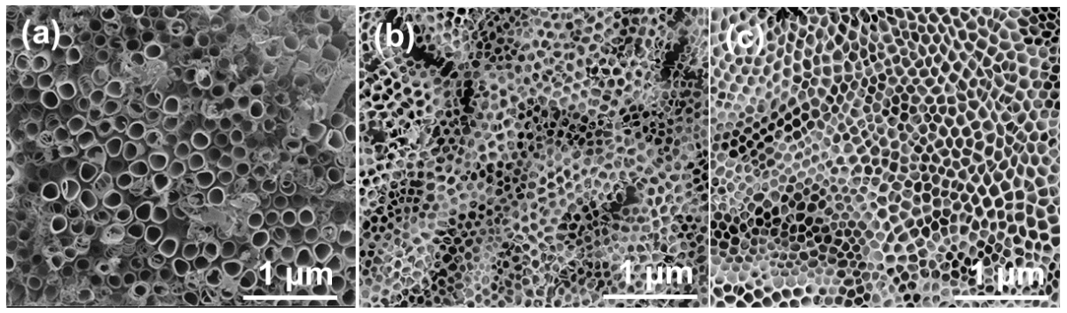

Fig. 1 The SEM images of (a) TNTs-1, (b) TNTs-1, and (c) TNTs-3.
  - Photoelectrochemical performance of TNTs with different morphologies
To investigate the differences in photoelectrochemical performance among TNTs with varying morphologies, photoelectrochemical tests were conducted on the three different TNT samples, as illustrated in Fig. 2. Linear sweep voltammetry (LSV) results (Fig. 2a) indicate that TNTs-3 exhibits the highest current density, followed by TNTs-2 and then TNTs-1. This suggests that the network-like structure of TNTs-3 possesses superior electrocatalytic performance. Cyclic voltammetry (CV) results (Fig. 2b) are consistent with LSV, demonstrating that the network structure of TNTs provides a larger active surface area compared to tubular TNTs. Electrochemical impedance spectroscopy (EIS) results (Fig. 2c) show that TNTs-1, with its tubular structure, has the largest electrochemical impedance radius, indicating the highest resistance. In contrast, TNTs-2 and TNTs-3, with network structures, exhibit lower resistance, with minimal difference between them. These findings collectively suggest that TNTs with a network morphology have superior electrocatalytic activity compared to tubular TNTs. The I-t curve results (Fig. 2d) reveal that TNTs-1, with its tubular morphology, achieves the highest photocurrent density at approximately 16 μA/cm², followed by TNTs-2 and TNTs-3. This trend is the opposite of the electrochemical characterization results, indicating that tubular TNTs have the best photocatalytic performance. This might be attributed to the single-tube structure's ability to minimize the recombination of photogenerated electron-hole pairs. UV-vis diffuse reflectance spectroscopy (UV-vis DRS) (Fig. 2e) results show that tubular TNTs-1 have the best light absorption performance in the 200-800 nm range, followed by TNTs-2, with TNTs-3 having the poorest light absorption. This pattern aligns with the photocurrent results, further confirming that the tubular morphology of TNTs exhibits higher photocatalytic activity compared to the network structure. Therefore, the TNTs-1 with the optimal photocatalytic performance were selected for subsequent ionic liquid surface modification experiments.

Fig. 2 The (a) LSV, (b) CV, (c) EIS, (d) i-t curve, and (e) UV vis DRS results of TNTs with different morphology.
  - Experiment on CO₂ enrichment by ILs
To identify the anion with the best CO₂ enrichment performance, we selected [Bmim] imidazolium cation and four different anions to form imidazolium-based ionic liquids. We tested their ability to absorb low concentrations of CO₂, using ethylene glycol (EG) as the solvent with an EG: ILs volume ratio of 4:1. We compared the CO₂ absorption capacities of the ionic liquids under low CO₂ concentration (400 ppm CO₂ + N₂). The results are shown in Fig. 3. The findings indicate that the CO₂ absorption capacity of each ionic liquid increases with time. Among them, the ionic liquid with the [Tf₂N] anion exhibited the highest CO₂ absorption capacity, indicating its superior CO₂ enrichment ability, followed by the [BF₄] anion. Therefore, [Bmim][Tf₂N] was selected as the target ionic liquid for surface modification on the TNTs. This modification aims to enhance the CO₂ enrichment at the interface between aqueous solution and nanocomposite surface, facilitating the formation of a CO₂-rich surface that promotes C-C coupling between increased single-carbon intermediates adsorbed on the photocatalyst, thereby promoting two-carbon products generation.

Fig. 3 CO₂ absorption loadings of different ILs.
  - Structure and light absorption of photocatalysts
XRD analysis of the prepared TNTs revealed the presence of the Ti metal substrate and the predominant formation of anatase TiO₂, particularly the 101 crystal plane (Fig. 4a). The surface loading of ionic liquids did not alter the crystalline phase composition. UV-vis DRS results indicated that the TNTs exhibited absorption not only in the UV region but also in the visible and infrared regions, attributed to their unique nanotube structure (Fig. 4b). This extended light absorption enhances the photocatalytic activity. The surface modification of ionic liquids further increased the absorbance of the photocatalyst in the whole 200-800 nm range. This suggests that ionic liquids not only facilitate CO₂ enrichment but also enhance the light absorption capabilities of the photocatalyst.
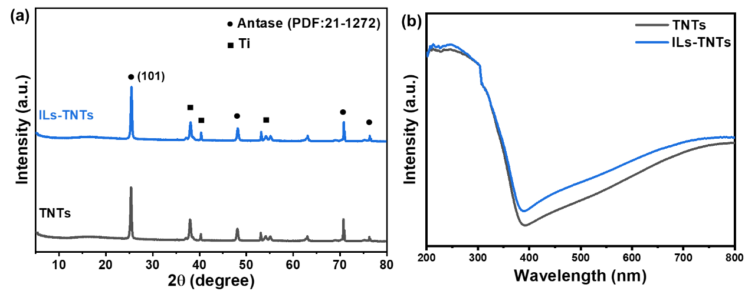

Fig.4 (a) XRD and (b) UV vis DRS results of TNTs and ILs-TNTs
  - Photoreduction of CO₂ to acetic acid
Compared to TNTs, the surface loading of ILs significantly increased the yield of the C2 product acetic acid, reaching 17.4 μmol gcat⁻¹ h⁻¹ (Fig. 5a). The results of the cyclic tests indicated that after multiple cycles, the yield of acetic acid from ILs-TNTs did not show a significant decrease (Fig. 5b). This demonstrates that ILs can remain on the surface of TNTs for extended periods during the reaction and are not easily detached.
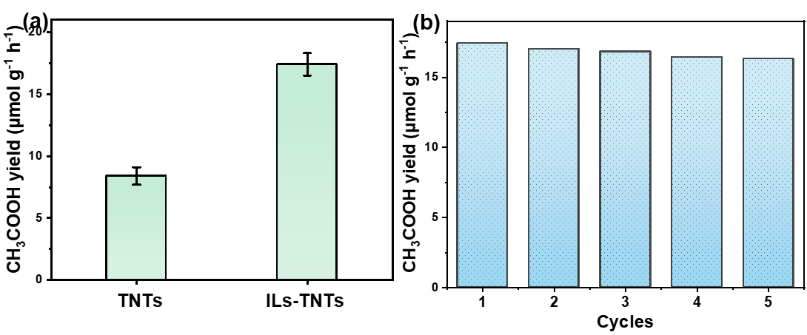

Fig.5 The (a) acetic acid yields and (b) cyclic tests of ILs-TNTs.
  - Exploration of the reaction mechanism
The contact angles on the catalyst surface were measured before and after ionic liquid loading (Fig. 6). The results showed that the prepared TNTs had a contact angle of 12 degrees, indicating a hydrophilic surface. In contrast, the ILs-TNTs exhibited a contact angle of 148 degrees, indicating a hydrophobic surface. This further confirmed the successful loading of ILs onto the TNTs surface. Moreover, the change in hydrophobicity ensured that during the process of photocatalytic CO₂ reduction reaction in an aqueous solution, the ILs did not easily detach from the TNTs surface, thus maintaining the durability of the ILs-TNTs catalyst.
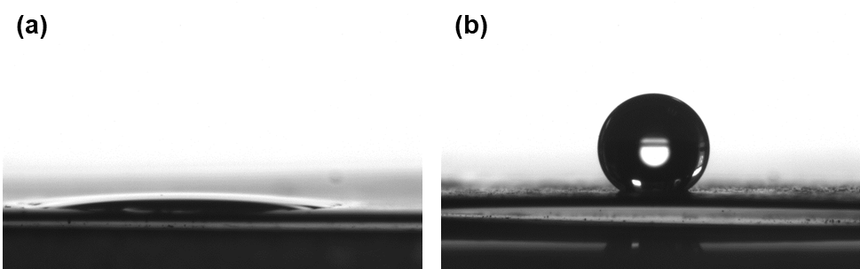

Fig. 6 Contact angles of (a) TNTs and (b) ILs-TNTs.
Based on the above experimental results, the mechanism of photocatalytic CO₂ reduction to acetic acid promoted by ILs-TNTs was deduced, as shown in Fig. 7. The single tubular structure of TNTs effectively promotes the separation of photogenerated electron-hole pairs, leading to high photocatalytic activity. The surface loading of ionic liquids enriches the catalyst surface with CO₂ from the aqueous solution, allowing more activated CO₂ and single-carbon intermediates to adsorb on the catalyst surface. This enrichment facilitates the forward progression of C-C coupling reactions, thereby promoting the formation of the two-carbon product, acetic acid.
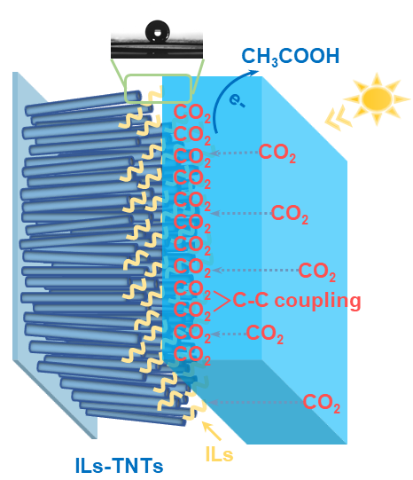

Fig. 7 Mechanism diagram of ILs-TNTs promoting photocatalytic CO₂ reduction to acetic acid production.
- Conclusion
TNTs arrays with different morphologies can be prepared with different amounts of water content of the electrolyte prepared by anodic oxidation. When the amount of water content is 14 vol%, a single tubular TNTs can be prepared, which has the optimal photocatalytic performance. When the amount of water content is 5 vol%, network-structured TNTs with superior electrocatalytic performance are obtained. The surface modification of ionic liquids enriches the catalyst surface with activated CO₂ and single-carbon intermediates, increasing the likelihood of C-C coupling and promoting the formation of the two-carbon product, acetic acid. Additionally, ionic liquids enhance the light absorption of the composite catalyst, further improving its photocatalytic performance.

References
- F.A. Rahimi, S. Dey, P. Verma, T.K. Maji, Photocatalytic CO₂ reduction based on a Re (I)-integrated conjugated microporous polymer: Role of a sacrificial electron donor in product selectivity and efficiency, ACS Catalysis 13(9) (2023).
- X. Chen, C. Zhuang, X. Wang, A. Liao, L. Li, Q. Liu, Y. Tang, C. Wu, Q. Shen, Z. Yu, Y. Zhou, Z. Zou, Two-step synthesis of laminar vanadate via a facile hydrothermal route and enhancing the photocatalytic reduction of CO₂ into solar fuel through tuning of the oxygen vacancies by in situ vacuum illumination treatment, ACS Applied Energy Materials 1(12) (2018).
- Y. Huang, P. Du, W.-X. Shi, Y. Wang, S. Yao, Z.-M. Zhang, T.-B. Lu, X. Lu, Filling COFs with bimetallic nanoclusters for CO₂-to-alcohols conversion with H₂O oxidation, Applied Catalysis B: Environmental 288 (2021).
- R. Das, K. Das, B. Ray, C.P. Vinod, S.C. Peter, Green transformation of CO₂ to ethanol using water and sunlight by the combined effect of naturally abundant red phosphorus and Bi₂MoO₆, Energy & Environmental Science 15(5) (2022).
- L. Wei, R. Guo, Y. Tang, J. Zhu, M. Liu, J. Chen, Y. Xu, Properties of aqueous amine based protic ionic liquids and its application for CO₂ quick capture, Separation and Purification Technology, 239 (2020).
- I.K. Swati, Q. Sohaib, S. Cao, M. Younas, D. Liu, J. Gui, M. Rezakazemi, Protic/aprotic ionic liquids for effective CO₂ separation using supported ionic liquid membrane, Chemosphere, 267 (2021).
- R. Lv, M. Zhang, H. Huang, S. Yuan, L. Liu, K. Li, J. Yuan, H. Hu, Self-doped TiO₂ nanotubes with surface modification by ionic liquids for enhanced photoreduction of CO₂ to acetic acid, Applied Surface Science 621 (2023).
- Y. Asai, H. Katsuragi, K. Kita, T. Tsubomura, Y. Yamazaki, Photocatalytic CO₂ reduction using metal complexes in various ionic liquids, Dalton Trans, 49 (2020).
- Y. Wang, K. Deng, L. Zhang, Visible light photocatalysis of BiOI and its photocatalytic activity enhancement by in situ ionic liquid modification, The Journal of Physical Chemistry C, 115 (2011).
- F.A. Rahimi, S. Verma, T.K. Maji, Photocatalytic CO₂ reduction: Role of a sacrificial electron donor in product selectivity and efficiency, ACS Catalysis 15(12) (2024).

